Monitoring / On-Call Approval Form

Employee Name: Nikunj Adhaduk _

Manager Name: Yaser Shadmehr
.
Monitoring Hours
Date of Monitoring (mm/dd/yyyy) | Project | Reason | Number of Hours
9/15/2025 | Scene ITOPS | ITOPS Support | 6
9/16/2025 | Scene ITOPS | ITOPS Support | 6
TOTAL |  |  | 12

On-Call Payment
Dates On-Call (mm/dd/yyyy – mm/dd/yyyy) | # of Weeks | Rate
9/07/2025 – 9/13/2025 | 1 | 200
9/14/2025 – 9/20/2025 | 1 | 200
11/02/2025 – 11/08/2025 | 1 | 200
TOTAL |  | 600
Approvals
Employee Signature: 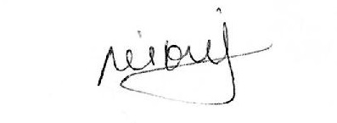 | Date:  Nov 14, 2025
Manager Signature: | Date:  Nov 14, 2025

Please submit to Payroll once approved.

Description
Date of Monitoring | Hours | Reason
Sept 15 – 16, 2025 | 12 | 2 Days full after-hours ITOPS support from 5 to 11 PM
Nov 5, 2025 | 4 | July 30 PROD slot deployment 3 to 6 PM

